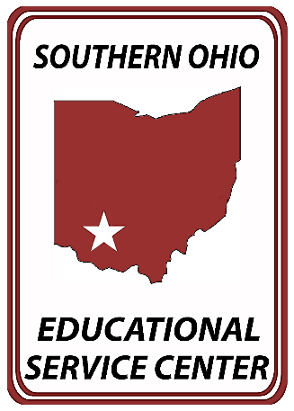

Press Release: Immediate
TO: Wilmington News Journal
Contact: Stephanie Huber
shuber@southernohioesc.org
937-382-6921 ext. 1036
Southern Ohio ESC

On Monday, April 15, 2024, the Ohio Educational Service Center Association (OESCA) recognized Ohio’s top students from across the state during the 35th Annual Franklin B. Walter All-Scholastic Awards Program, held at the Nationwide Hotel and Conference Center in Lewis Center, Ohio, following the OESCA’s annual Spring meeting.
The awards program, named in honor of Ohio’s 31st State Superintendent of Public Instruction, Franklin B. Walter, was established in 1989 by OESCA to promote and recognize outstanding student leaders for their academic achievement and service to their schools and communities. One senior from each county in Ohio was eligible to receive this annual honor.

Southern Ohio Educational Service Center selected four senior high school students from Adams, Clinton, Fayette, and Highland Counties for their academic success and school and community service. Students were selected based on their school grades, test scores, activities, an essay detailing their short-term and long-term goals, both academically or professionally and personally, and a letter of recommendation from an educator or individual that positively impacted their lives.

Pictured from LT to RT: Tim Davis, Hillsboro City Superintendent, Nicole Studebaker, Scarlett Studebaker, Jennifer Felker, Superintendent of ESC of Western Reserve and President of OESCA 2023-24 Executive Committee, and Curt Bradshaw, Southern Ohio ESC Assistant Superintendent

Scarlett Studebaker, Highland County recipient – Ms. Studebaker will graduate from Hillsboro City High School and plans to attend Miami University and major in Speech Pathology / Audiology.

Ms. Studebaker wrote: “My life goal is to continue my passion of expressing myself through
music and utilize my musical skills in the field of Speech Pathology and Audiology therapy.”

SOESC Superintendent Ms. Beth Justice said, “Ms. Studebaker truly represents the best of the best in the region, and I want to congratulate her on her many accomplishments. On behalf of SOESC, we thank you for being a leader for our future and wish you the very best.”

Southern Ohio Educational Service Center provides specialized academic and support services to twelve school districts in Adams, Clinton, Fayette, and Highland Counties. Districts receive services from school improvement consultants, gifted and special education consultants, speech pathologists, psychologists, and special education teachers.

