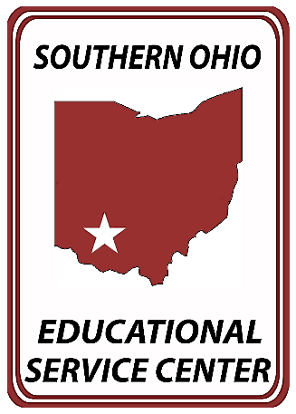

Press Release: Immediate
TO: Wilmington News Journal
Contact: Stephanie Huber
shuber@southernohioesc.org
937-382-6921 ext. 1036
Southern Ohio ESC

On Monday, April 15, 2024, the Ohio Educational Service Center Association (OESCA) recognized Ohio’s top students from across the state during the 35th Annual Franklin B. Walter All-Scholastic Awards Program, held at the Nationwide Hotel and Conference Center in Lewis Center, Ohio, following the OESCA’s annual Spring meeting.
The awards program, named in honor of Ohio’s 31st State Superintendent of Public Instruction, Franklin B. Walter, was established in 1989 by OESCA to promote and recognize outstanding student leaders for their academic achievement and service to their schools and communities. One senior from each county in Ohio was eligible to receive this annual honor.

Southern Ohio Educational Service Center selected four senior high school students from Adams, Clinton, Fayette, and Highland Counties for their academic success and school and community service. Students were selected based on their school grades, test scores, activities, an essay detailing their short-term and long-term goals, both academically or professionally and personally, and a letter of recommendation from an educator or individual that positively impacted their lives.

Pictured from LT to RT: Brad Turner, Deborah Turner, Emily Turner, Julie Reisinger, Miami Trace High School Guidance Counselor, and Curt Bradshaw, Southern Ohio ESC Assistant Superintendent

Emily Turner, Fayette County recipient – Ms. Turner will graduate from Miami Trace High School and plans to attend Case Western Reserve University and major in Astronomy and Engineering Physics.

Ms. Turner wrote: “Along with my goal to expand society’s knowledge of the universe, I hope to instill in others a sense of wonder and appreciation for the world and ignite their desire to learn. I have already started this journey at my school. I founded Kids in STEM, a program where high school students arrange and lead interactive STEM activities with elementary classes. Through Kids in STEM, I have discovered how to share my knowledge to empower students with a drive to explore the world. Making science accessible to people from all backgrounds will foster new and creative ideas. My goal is to continue my work in college through educational outreach programs.”

SOESC Superintendent Ms. Beth Justice said, “Ms. Turner truly represents the best of the best in the region, and I want to congratulate her on her many accomplishments. On behalf of SOESC, we thank you for being a leader for our future and wish you the very best.”

Southern Ohio Educational Service Center provides specialized academic and support services to twelve school districts in Adams, Clinton, Fayette, and Highland Counties. Districts receive services from school improvement consultants, gifted and special education consultants, speech pathologists, psychologists, and special education teachers.

