**Norwayne H.S. Senior Class –Tuesday May 6th, 2025**

**Seniors, please arrive in the HS gym no later than 7:45am – photo at 8am**

You can also order online [www.martysstudio.com](http://www.martysstudio.com) Click on order school portraits – school code is: Norwayne Senior

Marty’s Studio will be taking the senior class as a group Please order online or print off this form and give your order to the HS office. We will accept orders online or in the office until the first week of May. You can also give your order to Marty’s Studio photographer on the day of the picture. Your portraits will be delivered to the school within 2 -3 weeks. Cash or checks made payable to: **Marty’s Studio 330-345-7151**

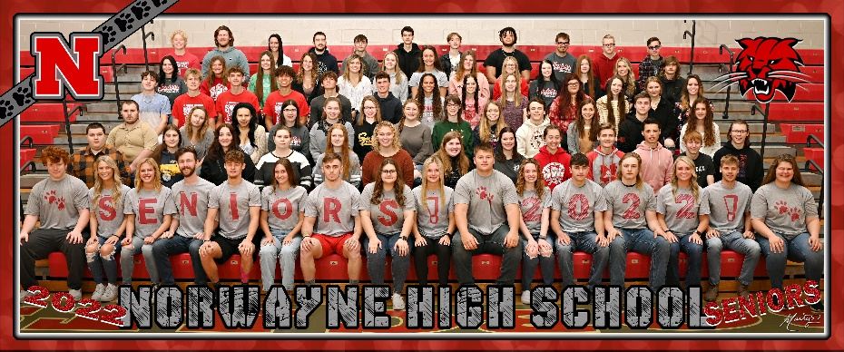

PLEASE CHECK YOUR SELECTION: ______ Senior Class Group Picture 24x10 **$20.00**

______ Senior Class Group License Plate **$17.00**

Student’s Name___________________________________________________MailingAddress__________________________________________

City_______________ State_____Zip___________ Phone__________________ Total Amount Enclosed $________________

Order Online: <https://vando.imagequix.com/g1001243235>