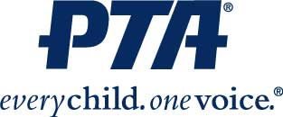

South-Western City Schools Council of PTAs
Membership Competition
Presented by: Katie Holcomb – SWCS Council of PTAs Membership Chairperson
Would your Unit like an opportunity to win $100?

South-Western Council of PTAs has decided to hold another Membership Challenge this school year and your unit could win $100 for participating!

We will be awarding $100 to the Top 3 PTA/PTSA Units who increase their membership percentage the most from last school year’s totals. I already have all of last year’s totals, so you do not need to report anything to me.

The only thing that you have to do is make sure that your unit is a Unit in Good Standing, by Ohio PTA guidelines and that your unit’s PTA Memberships are all entered into Givebacks (formerly MemberHub) by April 1, 2024 and I will do the rest. If you need assistance with using Givebacks and making sure that your PTA Memberships are submitted, please let me know.

Remember that gaining Memberships is a year-round goal that EVERYONE in your unit should be attempting to achieve. It is not a one person job.

If you have any questions, please contact Katie Holcomb at keiloandhooch@yahoo.com

