South-Western Council
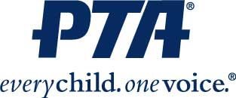

ATTENTION ALL SWCS PTA UNITS
Council dues of $150 are due for the 2023/2024 school year.

Please remit payment of dues to the Council Treasurer:
Chad Chaffins
4172 Marsol Ave. Grove City, 43123
614-570-8498
Chadchaffins7@gmail.com

Please make checks payable to: South-Western Council of PTAs
Due date: November 1, 2023

You may also wish to include your unit’s donation to the Shoe Fund. Please use the form below to specify the amount you are sending in order to place the money in the appropriate budget. A shoe fund donation in any amount is appreciated.
…………………………………………………………………………………………………………………………………………………..

SWCS Council of PTAs / Council Dues

Name of PTA Unit: _________________________________________________

Council Dues: $ _________ Shoe Fund: $ _________

Total Amount Enclosed: ________________ Check #: _________________

